Swarms
If you have a swarm of bees, please read this text before contacting the voluntary swarm coordinator. Contact numbers are given at the bottom of the web page.
Swarming is a natural process in the life of a honey bee colony. Swarming occurs when a large group of honey bees leaves an established colony and flies off to establish a new colony. Swarming is a natural method of propagation that occurs in response to crowding within the colony. Swarming usually occurs in late spring and early summer and begins in the warmer hours of the day.
Honey bee swarms may contain several hundred to several thousand worker bees, a few drones and at least one queen. Swarming bees fly around briefly and then cluster on a tree limb, shrub or other object. Clusters usually remain stationary for an hour to a few days, depending on weather and the time needed to find a new nest site by scouting bees. When a suitable location for the new colony, such as a hollow tree, is found the cluster breaks up and flies to it. The BBKA web site has further information about swarms in roof and wall cavities.
Usually honey bee swarms are not highly dangerous under most circumstances. Swarming honey bees feed prior to swarming, reducing their ability to sting. As the bees are away from their nest (offspring and food stores) they are less defensive and are unlikely to sting unless provoked.
In most situations when a honey bee swarm is found on a tree, shrub or house you do not need to do anything. Swarms are temporary and the bees will move on if you patiently ignore them.
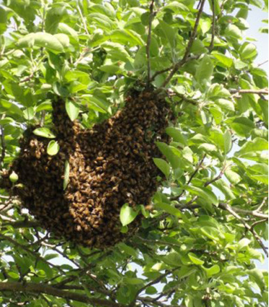Swarm in a tree
Swarm Coordinators will not remove bumblebees but may be able to give useful information.
WASPS can be unpredictable and aggressive – leave well alone. They are distinctively black and yellow in clearly defined bands. They will nest in the ground or any convenient space and have been found in shrubs in a protected part of the garden. Their nests are a distinctive spherical in shape and look like grey paper. If a pest, please refer to your local council Pest 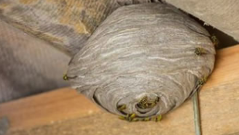Wasp Nest
Control Office or a professional pest control company.

Swarm Coordinators only deal with honey bee swarms and not wasps.
CONTACTS
Remember that the contact below can only provide assistance with honey bee swarms. Furthermore, they can only enter property with the consent of the owner/tenant and may not be able to assist where the bees are inaccessible. No charge is usually made for collecting a swarm although the collector may request expenses.
Before contacting your local swarm collector, please have the following details to hand
- Size of the swarm – size of a rugby ball, a football, a tennis ball.
- Location of the swarm on the property and how accessible it is.
- How long the swarm has been there.
- If possible a photo of the swarm so we can confirm the type of bee.
- Your address and phone number is needed too.

f you are concerned about a swarm of honey bees you can contact our swarm control coordinator on
swarmteam@doncasterBKA.org.uk
We will try to help but no guarantee is given for this service as we have restrictions on our insurance for swarm collections.

